*Data Flow Diagram*

The DFD (also known as the bubble chart) is a simple graphical formation that can be used to represent a system in terms of the input data to the system.DFDs can also be used for the visualization of data processing (Structure Design).

On a DFD, data items flow from an external data source on an internal data store to an internal data store or an external data sink, via internal process.

The main Reason why the DFD technique is so popular is probably because of the fact that DFD is a very simple formation, it simple to understand ad use. A DFD model uses a very limited number of primitive symbol to represent the functions performed by a system and the data flow among the functions.

The symbols are:

External Entity

Process

Data store

Data Flow

*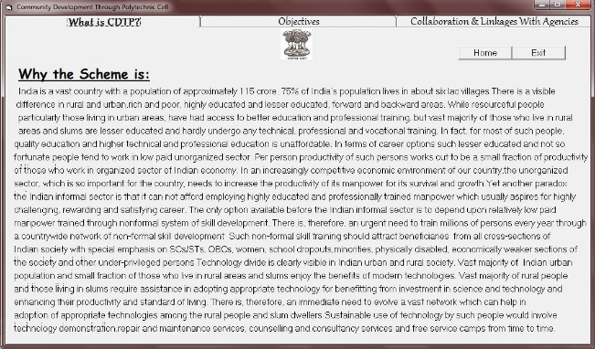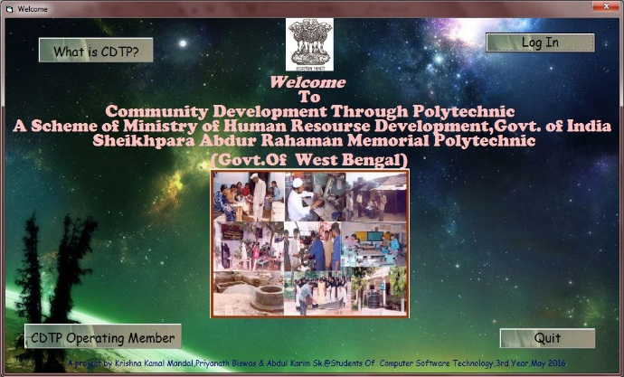Diagram*

Home

What is CDTP?

CDTP Operating Member

Collaboration with the agencies

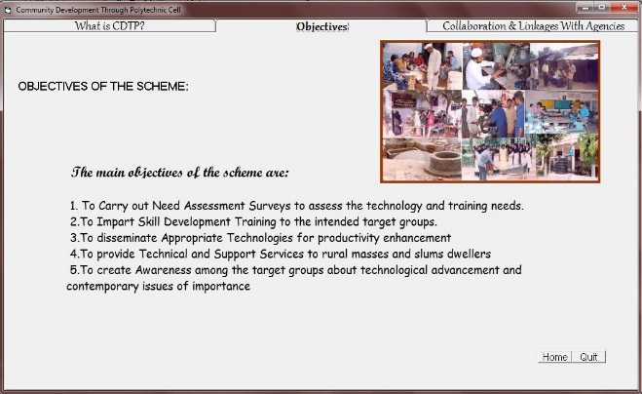

Home

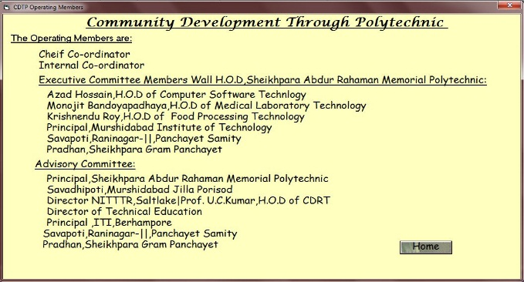

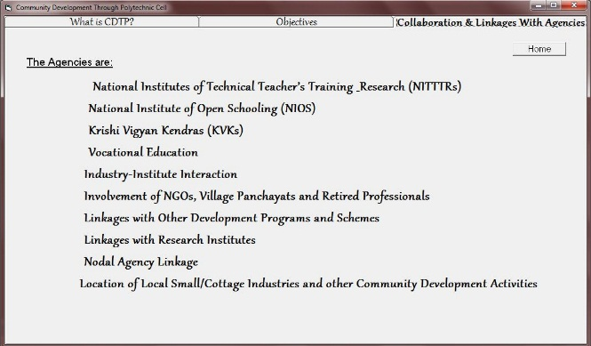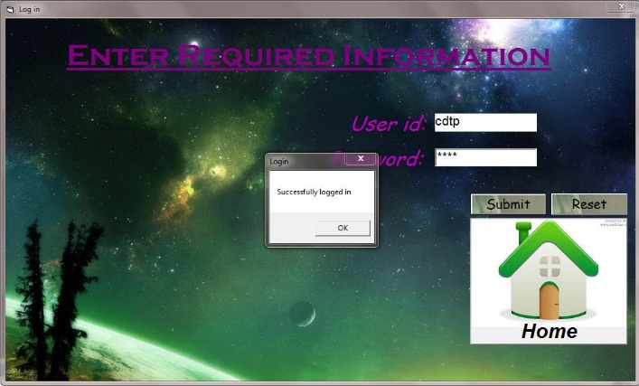

Submit

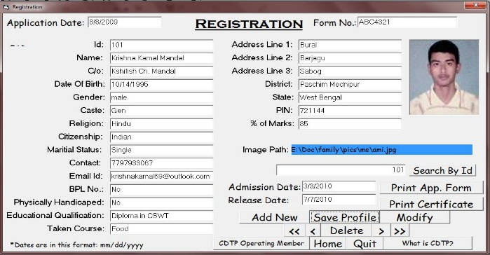

OK

Print Certi- ficate

<<

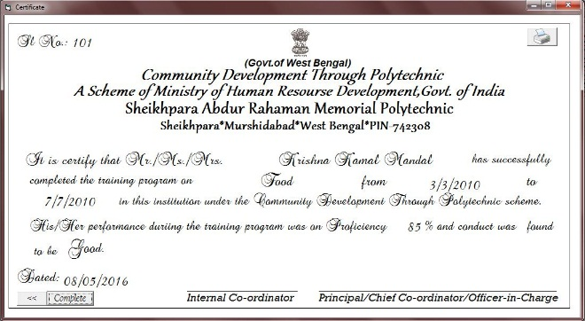

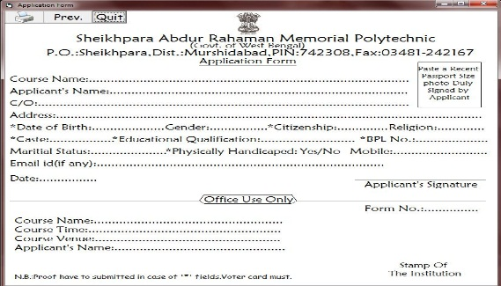

Prev.

Print Application Form

***Form Description***

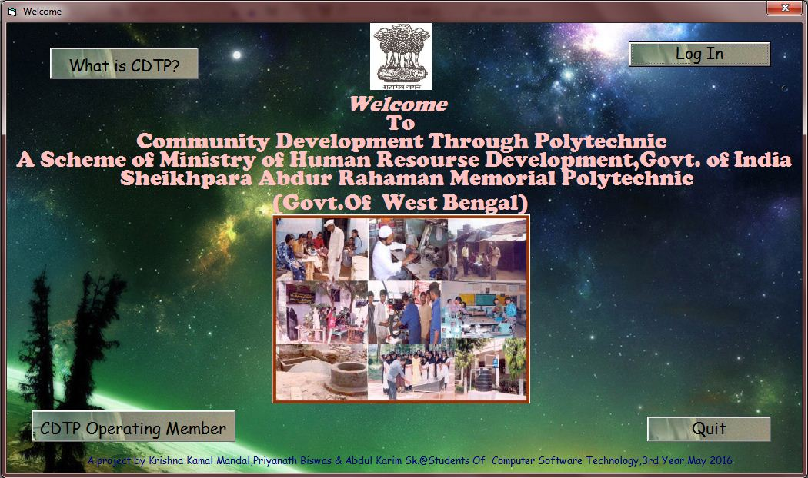The user is welcomed by this page. From this page you can go to CDTP information, operating member wall & Log in Form.

*The Page consist of four buttons:*

* *What is CDTP?*
* *CDTP Operating Members*
* *Log In*
* *Quit*

***CODES***

* *What is CDTP?*

Private Sub cdtp_Click()

Me.Hide

About.Show

End Sub

* *Operating Members*

Private Sub oper_Click()

Unload Me

opm.Show

End Sub

* *Log In*

Private Sub log_Click()

Unload Me

login.Show

End Sub

* *Quit*

Private Sub end_Click()

End

End Sub

If you press the **“What is CDTP?”** button you will face the form on next page.

***Form Description***

This page consist of 3tabs & 2buttons with general information.

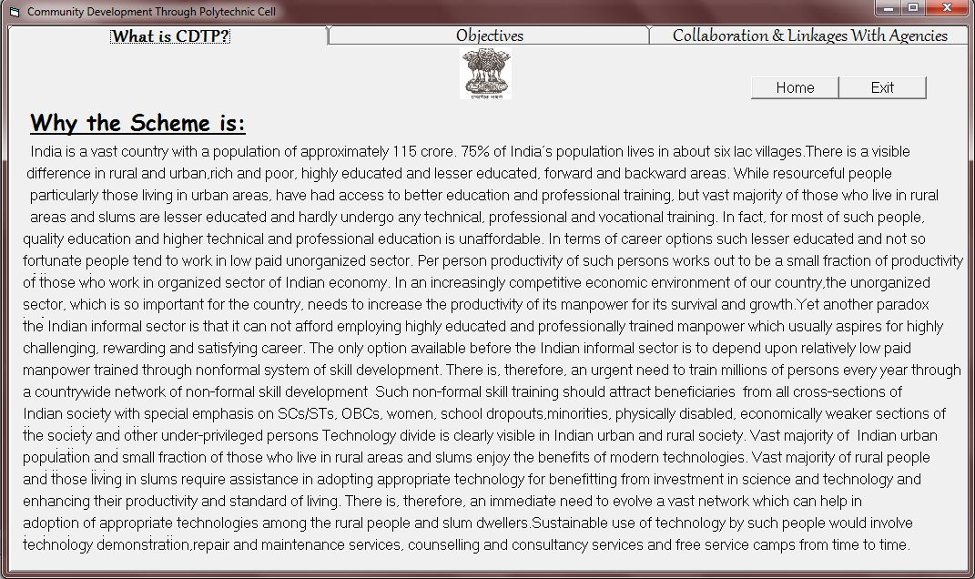

***CODES***

* Home

Private Sub hm_Click()

init.Show

Me.Hide

End Sub

* Exit

Private Sub Command1_Click()

init.Show

Me.Hide

End Sub

Here, if you change the tabs you face the 2tabs & 3buttons discussed on next page.

***Tab Description***

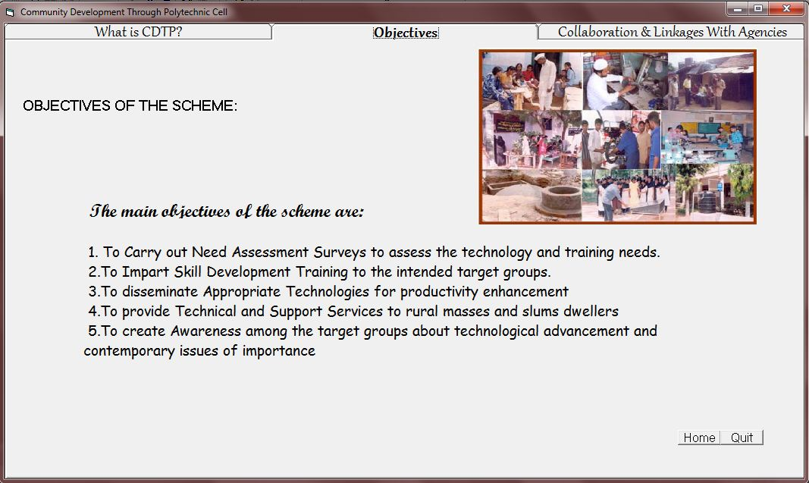

***CODES***

* **Home**

Private Sub Command1_Click()

init.Show

Me.Hide

End Sub

* **Quit**

Private Sub exit_Click()

End

End Sub

***Tab Description***

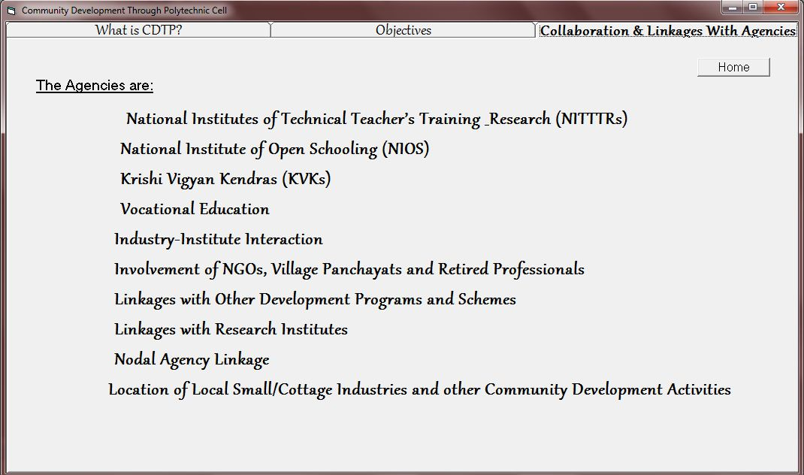

***CODES***

* ***Home***

*Private Sub home_Click()*

*init.Show*

*Me.Hide*

*End Sub*

*After that you are in Welcome form & from here you can go to the form CDTP operating member page.*

***Form Description***

*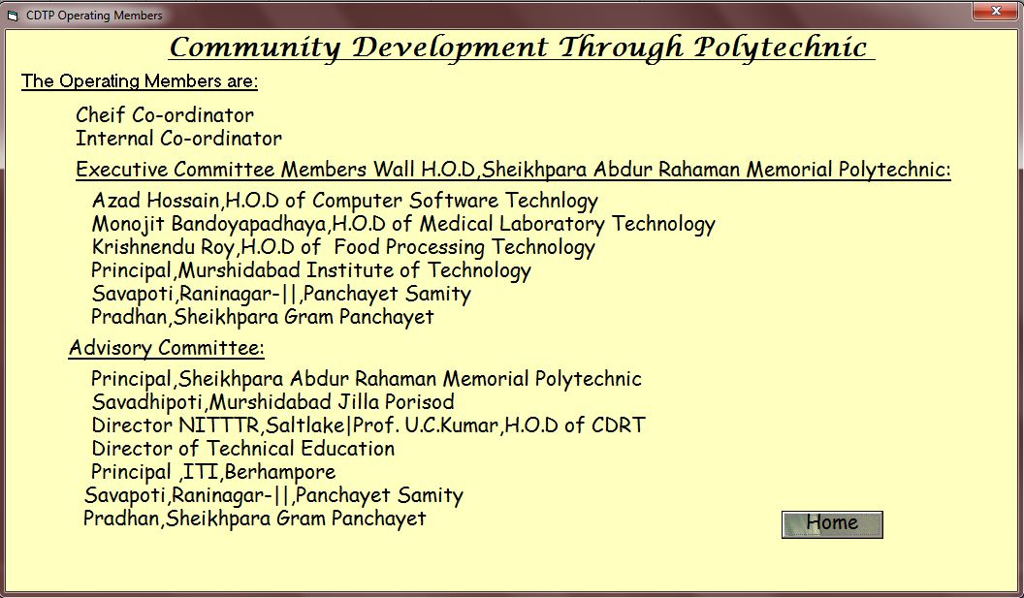So, from here you can go to the Welcome page.*

***CODES***

* ***Home***

Private Sub Command1_Click()

Me.Hide

init.Show

End Sub

By returning in home page clicking by Log In button you face the page like as next page…

***Form Description***

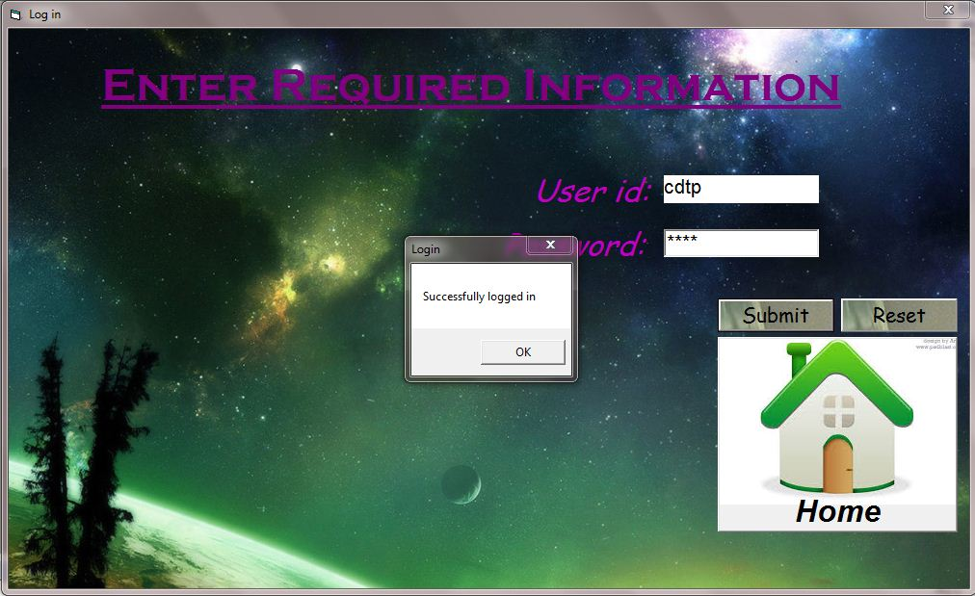If you know the user id & password then you can able to go to registration Form. This page consist of 3 buttons describe below.

***CODES***

In this form a function has defined like that:

Private Sub TBclear()

Text1.Text = ""

Text2.Text = ""

End Sub

& the codes of buttons are:

* ***Home***

Private Sub home_Click()

init.Show

Unload Me

End Sub

* **Submit**

Private Sub Submit_Click()

If Text1.Text = "cdtp" Then

If Text2.Text = "cdtp" Then

MsgBox "Successfully logged in", , "Login"

r.Show

Unload Me

Else

MsgBox "Login Failed!!Try Again", , "Login"

Text1.SetFocus

End If

Else

MsgBox "User id should be filled up!", , "Login"

Text1.SetFocus

End If

End Sub

* Reset

Private Sub reset_Click()

TBclear

End Sub

In This page if you are able to login then you can face the form registration & here you can add,delete,edit the data & return to home page or General information page & operating member page Or can be printed application form & Certificate or can be close the project.

***Form Description***

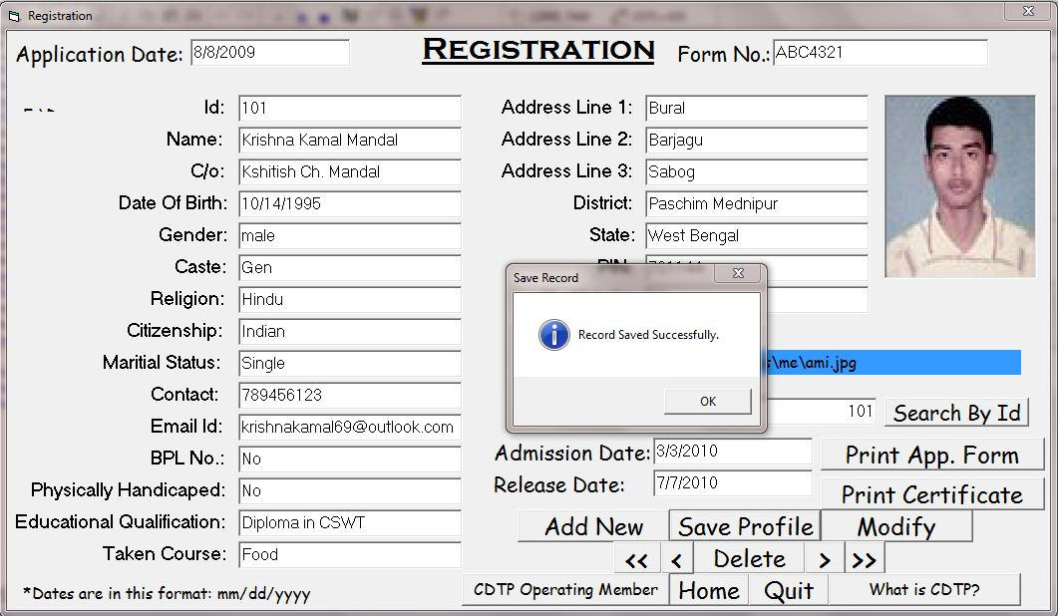The Registration form is Like that:

***CODES***

In this form some function is defined. The codes of buttons & functions are:

* **Form Load**

Private Sub Form_Load()

TBlock

End Sub

* **TBlock**

Private Sub TBlock()

Text1.Locked = True

Text2.Locked = True

Text3.Locked = True

Text4.Locked = True

Text5.Locked = True

Text6.Locked = True

Text7.Locked = True

Text8.Locked = True

Text9.Locked = True

Text10.Locked = True

Text11.Locked = True

Text12.Locked = True

Text13.Locked = True

Text14.Locked = True

Text15.Locked = True

Text16.Locked = True

Text17.Locked = True

Text18.Locked = True

Text19.Locked = True

Text20.Locked = True

Text21.Locked = True

Text22.Locked = True

Text24.Locked = True

Text25.Locked = True

Text26.Locked = True

Text27.Locked = True

lpic.Visible = False

End Sub

* **TBunlock**

Private Sub TBunlock()

Text1.Locked = False

Text2.Locked = False

Text3.Locked = False

Text4.Locked = False

Text5.Locked = False

Text6.Locked = False

Text7.Locked = False

Text8.Locked = False

Text9.Locked = False

Text10.Locked = False

Text11.Locked = False

Text12.Locked = False

Text13.Locked = False

Text14.Locked = False

Text15.Locked = False

Text16.Locked = False

Text17.Locked = False

Text18.Locked = False

Text19.Locked = False

Text20.Locked = False

Text21.Locked = False

Text22.Locked = False

Text24.Locked = False

Text25.Locked = False

Text26.Locked = False

Text27.Locked = False

lpic.Visible = True

End Sub

* **TBclear**

Private Sub TBclear()

Text1.Text = ""

Text2.Text = ""

Text3.Text = ""

Text4.Text = ""

Text5.Text = ""

Text6.Text = ""

Text7.Text = ""

Text8.Text = ""

Text9.Text = ""

Text10.Text = ""

Text11.Text = ""

Text12.Text = ""

Text13.Text = ""

Text14.Text = ""

Text15.Text = ""

Text16.Text = ""

Text17.Text = ""

Text18.Text = ""

Text19.Text = ""

Text20.Text = ""

Text21.Text = ""

Text22.Text = ""

Text23.Text = ""

Text24.Text = ""

Text25.Text = ""

Text26.Text = ""

Text27.Text = ""

Label17.Caption = ""

Image1.Picture = Nothing

End Sub

* **Add New**

Private Sub Add_Click()

ans = MsgBox("Are You Sure to ADD a new?", vbInformation + vbYesNo, "New")

If ans = vbYes Then

Adodc1.Refresh

TBunlock

TBclear

Text1.SetFocus

Adodc1.Refresh

Adodc1.Recordset.AddNew

End If

End Sub

* **Save Profile**

Private Sub save_Click()

On Error Resume Next

Adodc1.Recordset.Update

MsgBox ("Record Saved Successfully. "), vbInformation, "Save Record"

TBlock

End Sub

* **Modify**

Private Sub Edit_Click()

ans = MsgBox("Are U Sure to Modify data?", vbInformation + vbYesNo, "Modify Data")

If ans = vbYes Then

TBunlock

Text1.SetFocus

End If

End Sub

* **Delete**

Private Sub del_Click()

On Error GoTo err

ans = MsgBox("Are you Sure to Delete the Record?", vbExclamation + vbYesNo, "Delete Record")

If ans = vbYes Then

Adodc1.Recordset.Delete

Adodc1.Recordset.MovePrevious

End If

err:

If err.Number <> 0 Then

MsgBox ("Empty Data Row!Please click on " > " button"), vbCritical, "Error"

End If

End Sub

* **First Record**

Private Sub first_Click()

On Error GoTo err:

Adodc1.Recordset.MoveFirst

MsgBox ("This is the First Record in Database!"), vbExclamation, "Record Search"

If Adodc1.Recordset.BOF Then

Adodc1.Recordset.MoveFirst

MsgBox ("This is the First Record in Database!"), vbExclamation, "Record Search"

End If

err:

MsgBox "Try Again!"

End Sub

* **Last Record**

Private Sub last_Click()

On Error GoTo err:

Adodc1.Recordset.MoveLast

MsgBox ("This is the Last Record in Database!"), vbExclamation, "Record Search"

If Adodc1.Recordset.EOF Then

Adodc1.Recordset.MoveLast

MsgBox ("This is the Last Record in Database!"), vbExclamation, "Record Search"

End If

err:

MsgBox "Try Again!"

End Sub

* **Previous**

Private Sub prev_Click()

On Error GoTo err

Adodc1.Recordset.MovePrevious

If Adodc1.Recordset.BOF Then

Adodc1.Recordset.MoveFirst

MsgBox ("This is the First Record in Database!"), vbExclamation, "Record Search"

End If

err:

If err.Number <> 0 Then

MsgBox ("Please Try Again!"), vbCritical, "Error"

End If

End Sub

* **Next**

Private Sub next_Click()

On Error GoTo err

Adodc1.Recordset.MoveNext

If Adodc1.Recordset.EOF Then

Adodc1.Recordset.MoveLast

MsgBox ("This is the Last Record in Database!"), vbExclamation, "Record Search"

End If

err:

If err.Number <> 0 Then

MsgBox ("Please Try Again!"), vbCritical, "Error"

End If

End Sub

* **Home**

Private Sub home_Click()

Me.Hide

init.Show

End Sub

* **Load Picture**

Private Sub lpic_Click()

CommonDialog1.FileName = ""

CommonDialog1.Filter = "JPEG Files|*.jpg|GIF Files|* .gif|All Files|*.*"

CommonDialog1.ShowOpen

Label17 = CommonDialog1.FileName

If Len(Trim(Label17)) < 1 Then

Exit Sub

End If

Image1.Picture = LoadPicture(Label17)

End Sub

* **Quit**

Private Sub quit_Click()

End

End Sub

* **Search by id**

Private Sub Search_Click()

On Error Resume Next

Tbunlock

Adodc1.RecordSource = "Select *from Student where id='" & Text23 & "'"

Text1.Text = Val(Text23.Text)

Text2.Text = Adodc1.Recordset("nam")

Text3.Text = Adodc1.Recordset("fname")

Text4.Text = Adodc1.Recordset("dob")

Text5.Text = Adodc1.Recordset("gender")

Text6.Text = Adodc1.Recordset("caste")

Text7.Text = Adodc1.Recordset("religion")

Text8.Text = Adodc1.Recordset("citizenship")

Text9.Text = Adodc1.Recordset("marst")

Text10.Text = Adodc1.Recordset("mob")

Text11.Text = Adodc1.Recordset("email")

Text12.Text = Adodc1.Recordset("bpl")

Text13.Text = Adodc1.Recordset("ph")

Text14.Text = Adodc1.Recordset("eq")

Text15.Text = Adodc1.Recordset("cname")

Text16.Text = Adodc1.Recordset("add1")

Text17.Text = Adodc1.Recordset("add2")

Text18.Text = Adodc1.Recordset("add3")

Text22.Text = Adodc1.Recordset("district")

Text19.Text = Adodc1.Recordset("state")

Text20.Text = Adodc1.Recordset("pin")

Text21.Text = Adodc1.Recordset("marks")

Text24.Text = Adodc1.Recordset("apdt")

Text26.Text = Adodc1.Recordset("admdt")

Text27.Text = Adodc1.Recordset("reldt")

LabelNew.Caption = Adodc1.Recordset("picture")

Image1.Picture = LoadPicture(LabelNew)

TBlock

End Sub

* **Print App. Form**

Private Sub appform_Click()

Me.Hide

ppi.Show

End Sub

* **Print Certificate**

Private Sub Cert_Click()

abcd.Label25.Caption = Text1.Text

abcd.Label7.Caption = Text2.Text

abcd.Label10.Caption = Text15.Text

abcd.Label12.Caption = Text26.Text

abcd.Label14.Caption = Text27.Text

abcd.Label17.Caption = Text21.Text

Me.Hide

abcd.Show

End Sub

* **What is CDTP?**

Private Sub cdtp_Click()

Me.Hide

About.Show

End Sub

* **CDTP Operating Member**

Private Sub oper_Click()

Unload Me

opm.Show

End Sub

***Form Description***

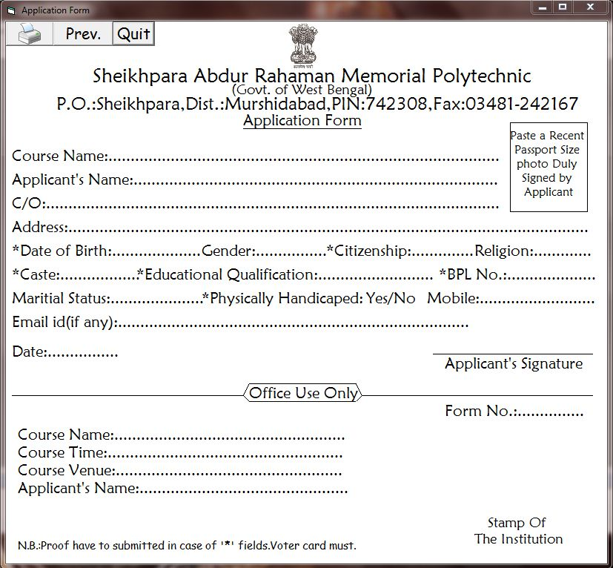From here you can print application form.

***CODES***

* **Print**

Private Sub cmdPrint_Click()

cmdPrint.Visible = False

cmdExit.Visible = False

pp.Visible = False

PrintForm

cmdPrint.Visible = True

cmdExit.Visible = True

pp.Visible = True

End Sub

* **Prev.**

Private Sub pp_Click()

Unload Me

r.Show

End Sub

* **Quit**

Private Sub cmdExit_Click()

End

End Sub

And if you want to print certificate then you have to return to registration form & then fetch the detail of the student whose certificate you want to print.

***Form Description***

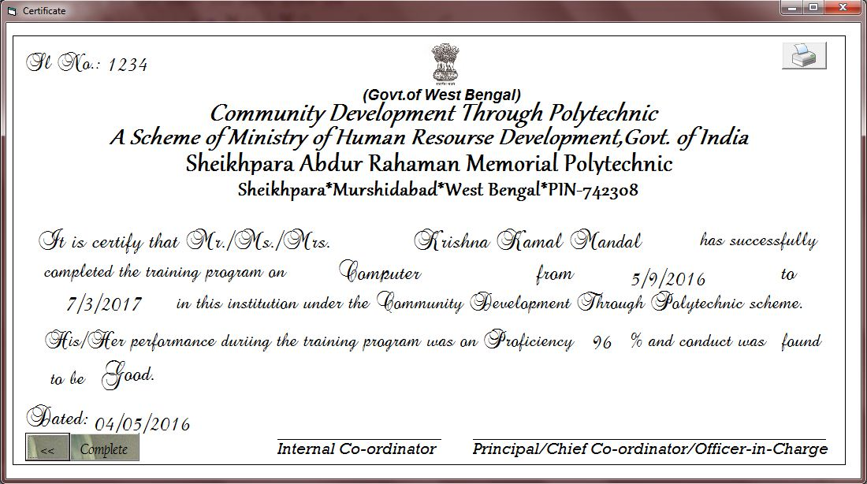Here required fields are filled & by print symbol you can print it.

***CODES***

* **Print**

Private Sub cmdPrint_Click()

cmdPrint.Visible = False

pp.Visible = False

complete.Visible = False

PrintForm

cmdPrint.Visible = True

pp.Visible = True

complete.Visible = True

End Sub

* **Previous**

Private Sub pp_Click()

Me.Hide

r.Show

End Sub

* **Complete**

Private Sub complete_Click()

End

End Sub

To issue the date of certificate as system date the form is load by following code:

Private Sub Form_Load()

Label23.Caption = Format$(Date, "dd/mm/yyyy")

End Sub